Facebook blocks photo of Neptune statue for being 'explicitly sexual'
Social network admits error after photo of 16th-century statue in Piazza del Nettuno was blocked for showing the body ‘to an excessive degree’
The statue of Neptune in the Piazza del Nettuno, Bologna, Italy
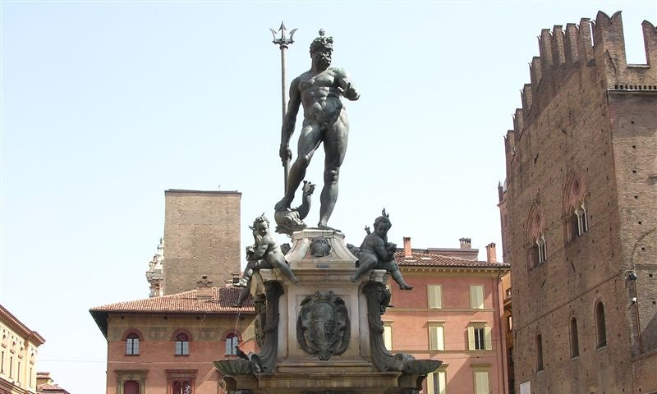
The statue of Neptune in the Piazza del Nettuno, cited by Facebook as ‘concentrating unnecessarily on body parts’. Photograph: Paolo Carboni/Creative Commons
Edward Helmore
Monday 2 January 2017 20.37 GMT Last modified on Tuesday 3 January 2017 01.51 GMT
View more sharing options
Shares
3,188
Comments
5
Facebook is facing renewed criticism after its software appears to have blocked a photograph of a 16th-century statue of Neptune that stands in the Piazza del Nettuno in the Italian city of Bologna, claiming it is “sexually explicit”.

Local writer Elisa Barbari had chosen the statue, which shows Neptune naked and holding a trident, to illustrate her Facebook page “Stories, curiosities and views of Bologna.” But the Nettuno picture fell foul of the social media giant’s privacy policies, the Daily Telegraph reported.

In a statement, Facebook told the artist: “The use of the image was not approved because it violates Facebook’s guidelines on advertising. It presents an image with content that is explicitly sexual and which shows to an excessive degree the body, concentrating unnecessarily on body parts.

“The use of images or video of nude bodies or plunging necklines is not allowed, even if the use is for artistic or educational reasons.”

Barbari responded with incredulity, posting on her Facebook page: “Yes to Neptune, no to censorship.”

She told the Telegraph: “I wanted to promote my page but it seems that for Facebook the statue is a sexually explicit image that shows off too much flesh. Really, Neptune? This is crazy!

“How can a work of art, our very own statue of Neptune, be the object of censorship?”
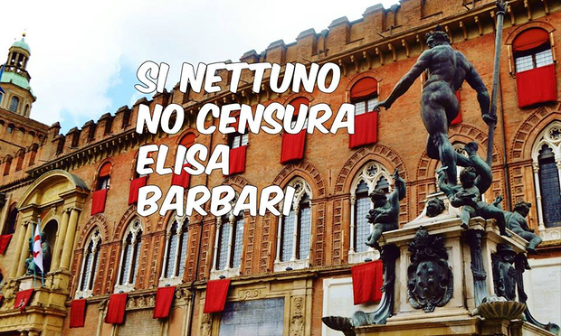
Elisa Barbari’s plea on Facebook: ‘Yes Neptune, no censorship.’
Facebook Twitter Pinterest
Elisa Barbari’s plea on Facebook: ‘Yes Neptune, no censorship.’ Photograph: Facebook
The statue was created in the 1560s by a Flemish sculptor called Jean de Boulogne, nicknamed by the Italians Giambologna, and it has dominated the piazza for approaching 500 years.

Advertisement

“Back in the 1950s, during celebrations for schoolchildren graduating, they used to cover up Neptune,” Barbari added. “Maybe Facebook would prefer the statue to be dressed again.”

A Facebook spokesperson later said in a statement that the censorship was a mistake.
“Our team processes millions of advertising images each week, and in some instances we incorrectly prohibit ads. This image does not violate our ad policies. We apologise for the error and have let the advertiser know we are approving their ad.”

Facebook’s overzealous censoring software has brought the social media giant into controversy with increasing frequency, even as it faces intense criticism on another front for doing too little to prevent the spread of “fake news”.

Last year, a Norwegian user was directed to remove the 1972 Pulitzer-winning “Terror of War” photograph of a naked girl running from napalm attacks during the Vietnam war from a post about images that changed history.

In that case, Facebook also claimed the image broke nudity rules. However, it later reversed its decision and issued an apology, saying the company recognized “the history and global importance of this image”.

“Because of its status as an iconic image of historical importance … we have decided to reinstate the image on Facebook where we are aware it has been removed,” the company said.

In that case, Facebook chief operating officer Sheryl Sandberg apologized to Norwegian prime minister Erna Solberg after the company deleted a post by her in which she shared the picture in solidarity with Tom Egeland, a writer who had included the Nick Ut picture as one of seven photographs he said had “changed the history of warfare”.

“These are difficult decisions and we don’t always get it right,” Sandberg wrote. “Even with clear standards, screening millions of posts on a case-by-case basis every week is challenging.

Advertisement

“Nonetheless, we intend to do better. We are committed to listening to our community and evolving. Thank you for helping us get this right.”

In January 2015, the company was accused of censoring photos of Copenhagen’s Little Mermaid statue for allegedly containing “too much bare skin or sexual undertones”.

Facebook says it restricts nudity because “some audiences within our global community may be sensitive to this type of content”. Among the content regularly blocked are images of genitals and bare buttocks.

Images of female nipples were forbidden unless a woman’s breasts were “actively engaged in breastfeeding” or where the image showed “breasts with post-mastectomy scarring”.

But Facebook’s issues with monitoring and removing content posted by its 1.4bn active users look set to continue.

In November, it was reported that software developed with Mark Zuckerberg’s support will allow third parties to monitor and suppress the visibility of posts.

The social media giant was accused of developing the software as part of its effort to get China to lift its seven-year ban on Facebook, imposed after the Urumqi riots in July 2009 in an effort to stem the flow of information about the unrest.

A Facebook spokesperson said: “We have long said that we are interested in China, and are spending time understanding and learning more about the country.”

Repeated accusations that Facebook places unnecessarily onerous standards on user content led to a shift in policy last October, when the company said it was introducing editorial standards analogous to those of a newspaper and would no longer censor graphic material that is “newsworthy, significant, or important to the public interest – even if they might otherwise violate our standards”.

“Our intent is to allow more images and stories without posing safety risks or showing graphic images to minors and others who do not want to see them,” Facebook executives Joel Kaplan and Justin Osofsky wrote announcing the change.

